BEST in Bath English Language Courses
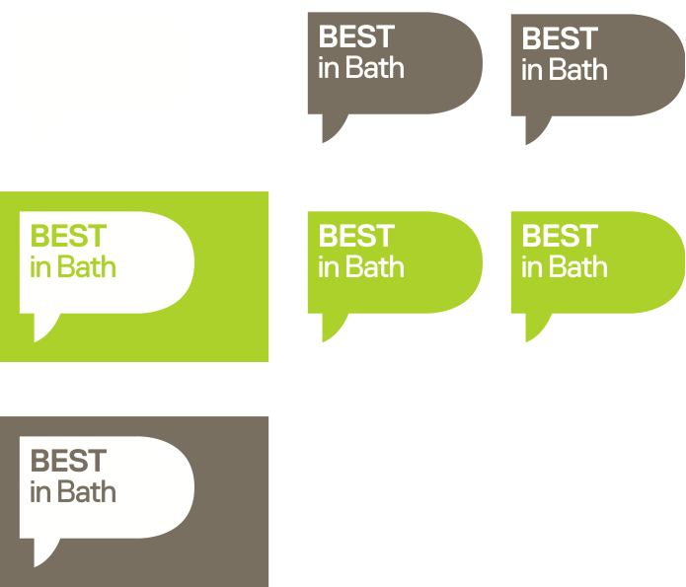

ENROLMENT FORM - ADULT COURSE (18+)

Personal information

Family name Masc / Fem Date of birth

First name E-mail

Address Telephone

Post code Nationality

Course information

Intensive 20 Intensive 30 Combined 5 Combined 10 1-1 1-1 How many hours per week?

Start date End date. No. of weeks

Accommodation information

Do you want Best in Bath to arrange your accommodation? Yes No

Start date End date
Would you accept a family who smokes? Yes No
Would you accept a family with: a cat? Yes No
a dog? Yes No

children? Yes No

Do you have a special diet? Yes No Please give details

Do you have an allergy/medical condition? Yes No Please give details

Transfers

Do you want an airport meeting service on arrival? Yes No Do you want a taxi transfer? Yes No

Flight details Date Time Airport Airline Flight Number

Arrival
Departure

September 2010

Payment

Declaration
I have read and understood the booking procedure and terms and conditions. I understand that full fees should be paid four weeks before the start date of the course.

Signature ________________________________ Date __________________

www.bestinbath.co.uk info@bestinbath.co.uk

